Alexander Cannell

Professor Robertson

Project 8-1:

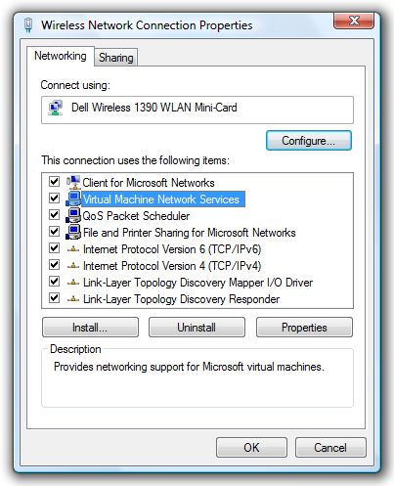

Show how to get to the wireless network Properties.

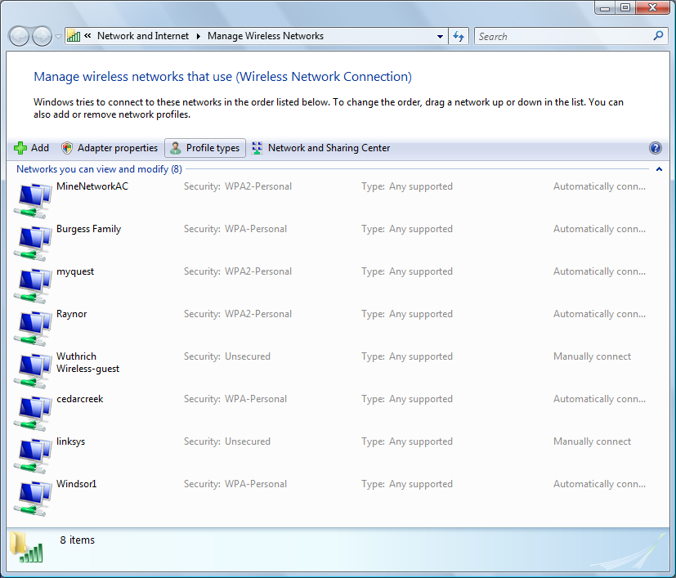

This shows where you can change and add and remove wireless networks.

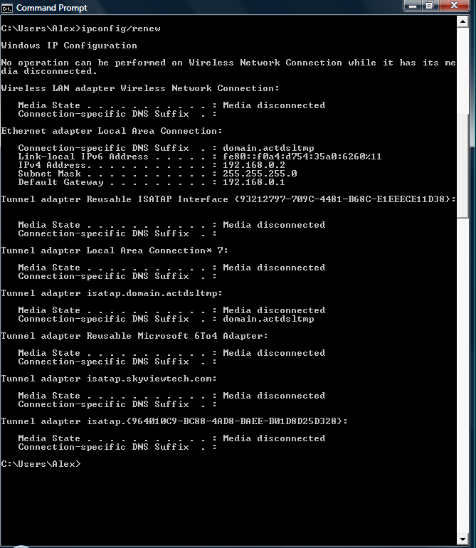

This shows the ipconfig renewal.

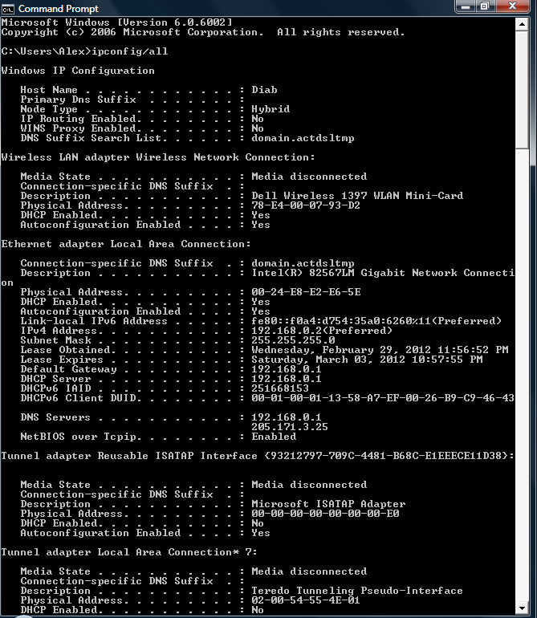

This shows the NIC properties, the access point address, and the IP address. My IP is 192.168.0.2, and access point 205.171.3.25.

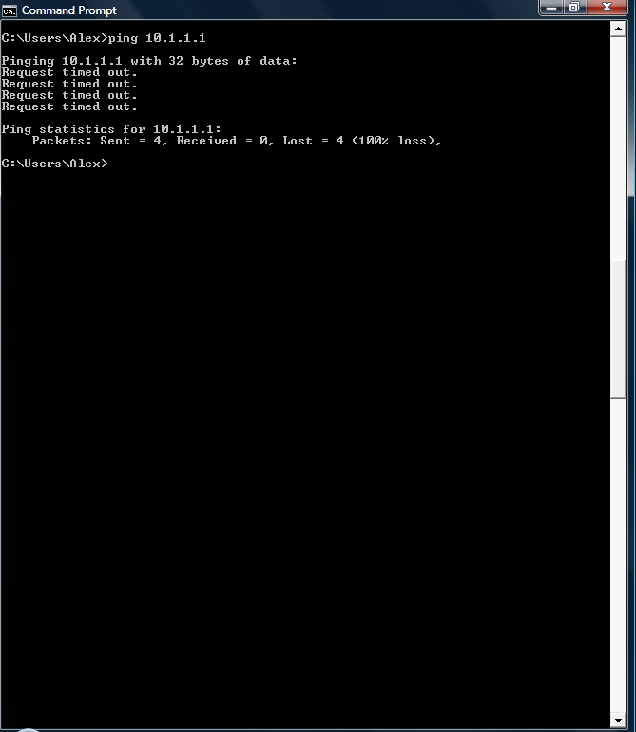

This is what I got when I pinged 10.1.1.1, which tells me that I’m not getting a response from the default gateway.

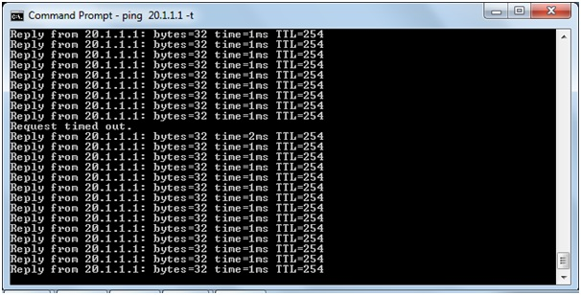

This is what I should have got, except this guy ping 20.1.1.1

Project 8-2:

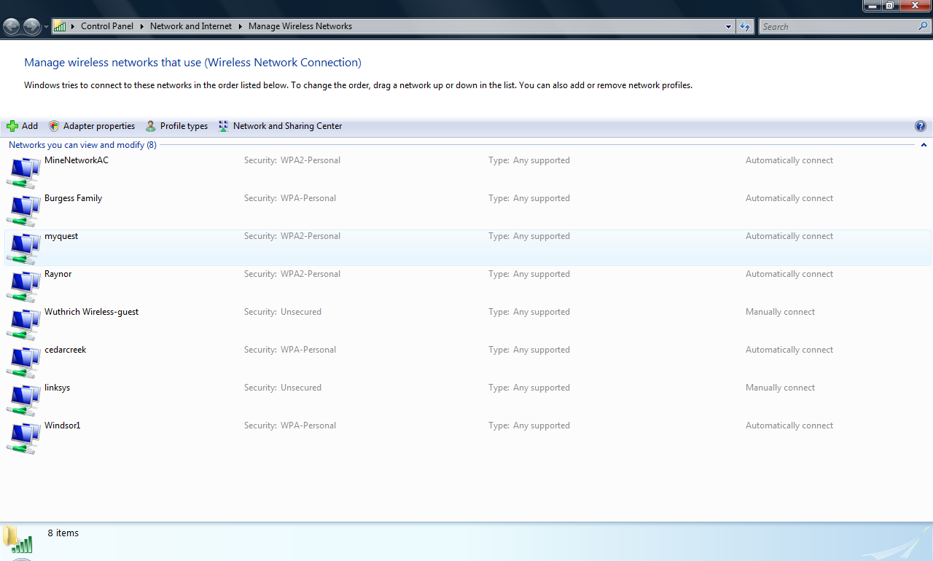

This shows the manage wireless network, where you can add, remove, and see existing saved wireless networks.

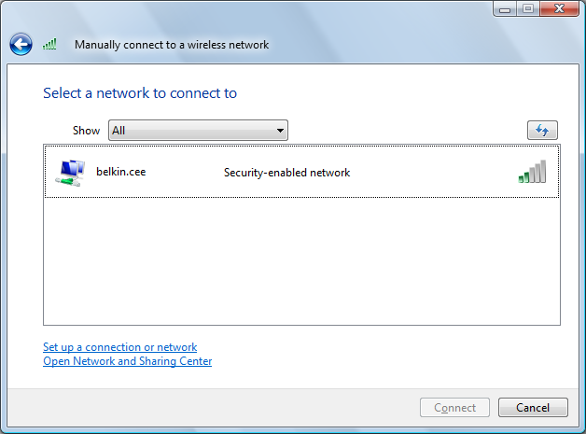

This shows all the networks that are in range of my computer, at the moment.

Project 8-3:

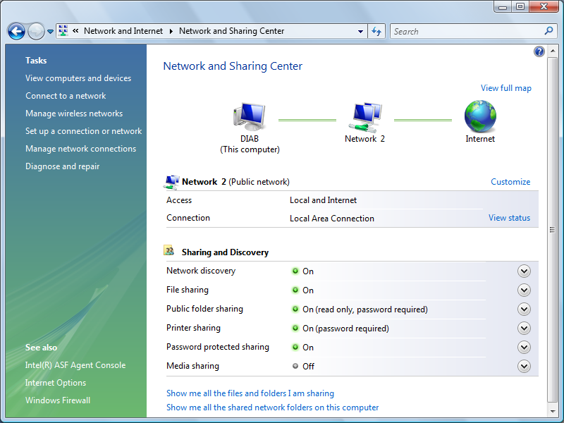

Network and sharing center

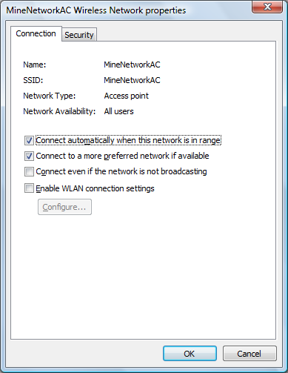

MineNetworkAC Wireless network properties

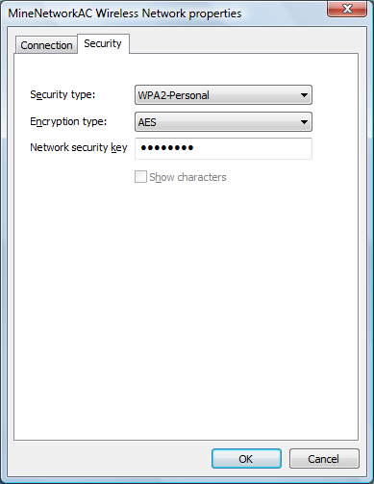

I clicked on the security tab, it shows my encryption type: AES, my Security type: WPA2, and my network password.

**What I did set up a wireless network.**

**What I learned is how to assign a SSID, ping the default gateway, how to manually connect to a wireless network, how to manage the network(add, remove, and see existing saved network SSID’s), and how to change the properties of existing SSIDS.**

**How this applies to a networking professional is a networking professional now a days will forsure need to learn how to set up a wireless network for their employeers, fellow employees, and custumers.**